2024 Water Quality - Grindstone Lake

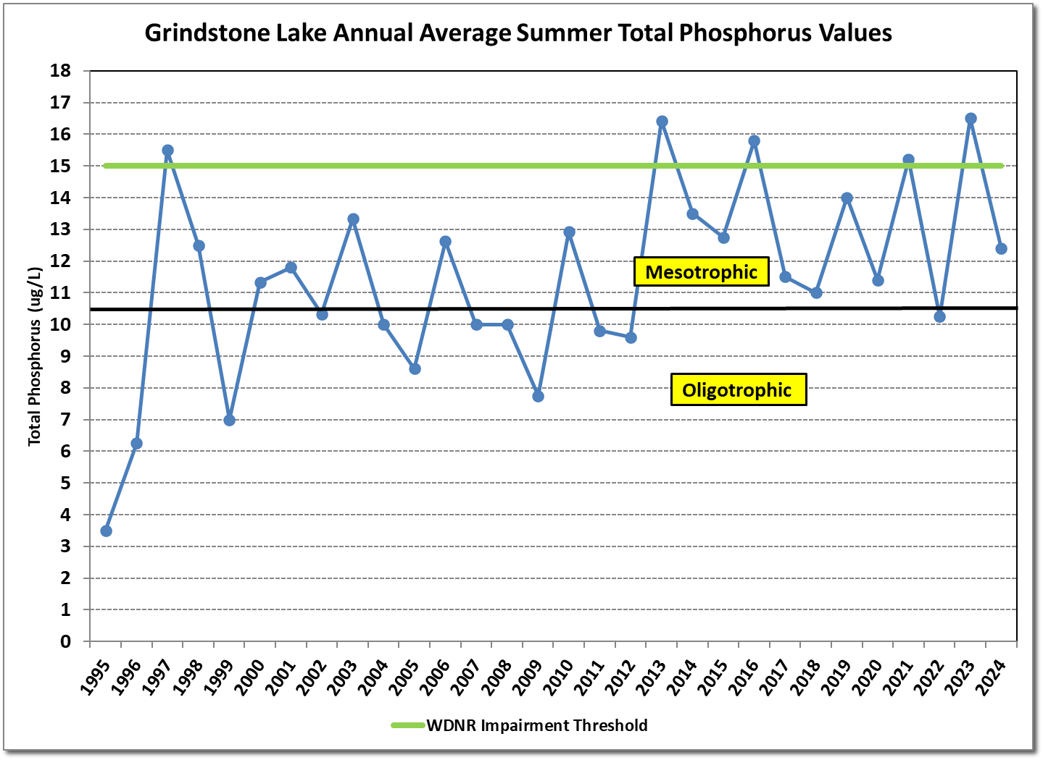
Total Phosphorus
12.4 ug/L
Phosphorus fuels algal growth. The impairment threshold for aquatic life and recreation is 15.0 ug/L. The five-year average is 13.2ug/L.
Phosphorus trends were evaluated using data from 1995-2024. No statistically significant trend was observed.

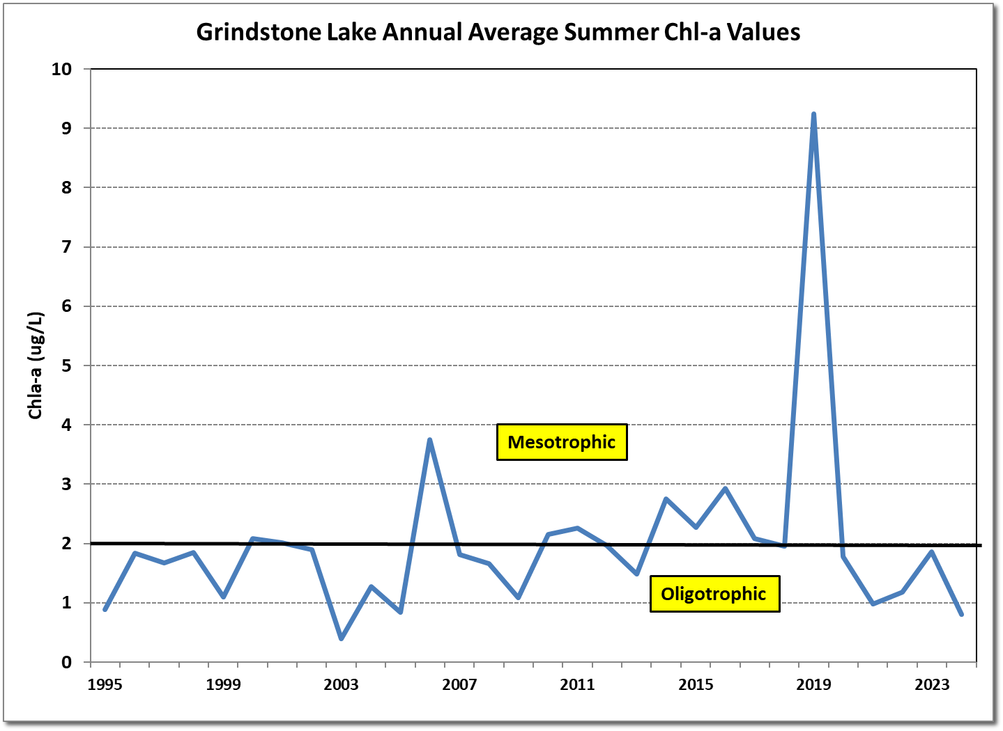
Chlorophyll a (Chl-a)
0.8 ug/L
Chl-a indicates algal productivity and abundance. Excessive algal growth can contribute to oxygen depletion and impact the two-story fishery habitat.
The impairment threshold is 8.0 ug/L. The 2024 average was 0.8ug/L This is the lowest growing season mean average ever recorded for the Lake. The 5-year average is 1.3 ug/L.
No significant trends were observed from the historical data.
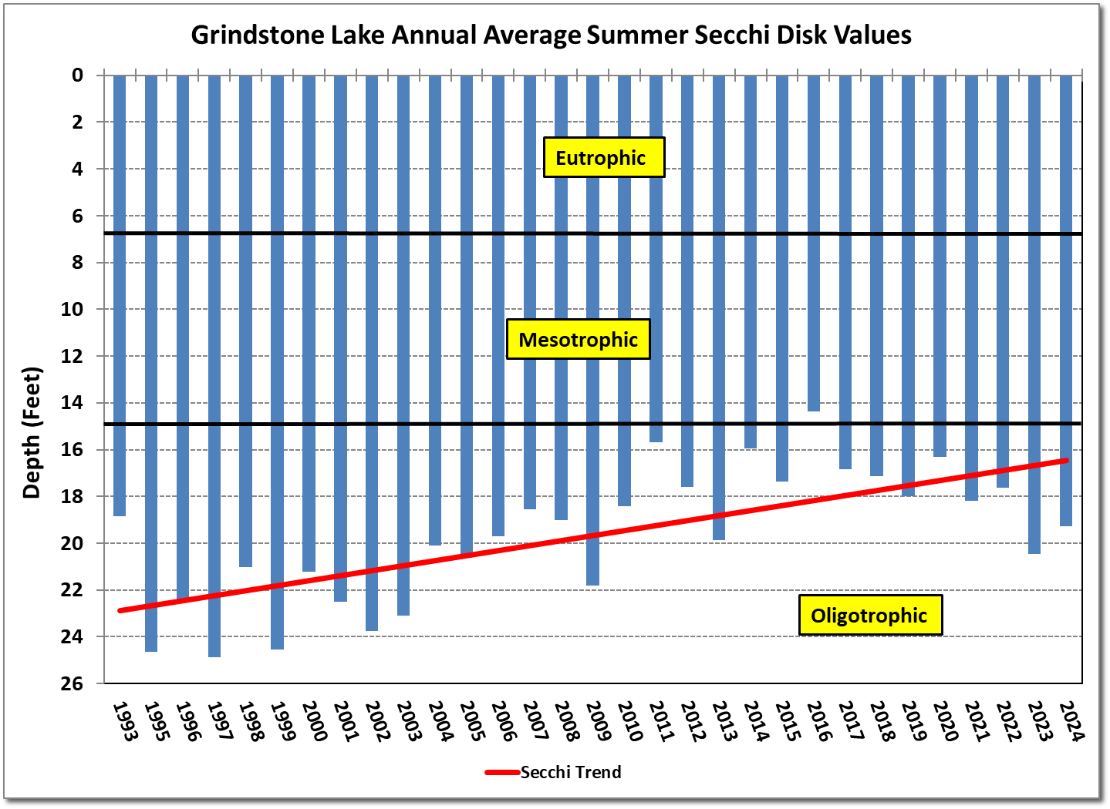
Water Clarity (Secchi) 19.3 Feet
The average water clarity during the summer of 2024 was 19.3 feet. This is slightly better than the 5-year average of 18.4 feet. However, a statistically significant trend of decreasing water clarity has been observed. Going back from 1993 to the present, this has been an estimated loss in clarity of nearly 6.6 feet. So, a little over 6 feet in the past 30 yrs.

